# Homework for 16 Beetroot lesson “Mobile apps testing”

## Beet Seed

### Протестуй роботу сайту “[ZooBonus](https://zoobonus.ua/en)” на мобільному пристрої + Заведи 5 відповідних баг репортів у файл Google Docs

1. **ZooBouns-1**

**Summary:** Non-English text displayed on the image in the "Free Shipping" section of the English site version.

**Priority:** 4 / **Severity:** 2

**Preconditions:** User is on “[Zoobonus.ua](http://zoobonus.ua)”

**Bug Description:** The "Free Shipping" section on the English version of the website contains an image with text in Ukrainian, which should be displayed in English.

**STR:**

1. Change language of the website to English;
2. Scroll to the "Free Shipping" section on general page;
3. Notice the text “Безкоштовна доставка” on the image;

**Expected Result:** The image in the "Free Shipping" section displays text in English.

**Actual Result:** The image in the "Free Shipping" section contains text in Ukrainian: "Безкоштовна доставка."

**Attachments:**



1. **ZooBonus-2**

**Summary:** Calendar for date selection on the birthday date field does not open on the pet breed selection page.

**Priority:** 2 / **Severity:** 1

**Preconditions:** User is on “[Zoobonus.ua](http://zoobonus.ua)”

**Bug Description:** The calendar used to select a date fails to open on the pet breed selection page, preventing users from choosing a date.

**STR:**

1. Navigate to the pet breed selection page;
2. Click on the date selection field.

**Expected Result:** The calendar widget opens, allowing the user to select a date.

**Actual Result:** The calendar widget does not open, and no date can be selected.

**Attachments:**

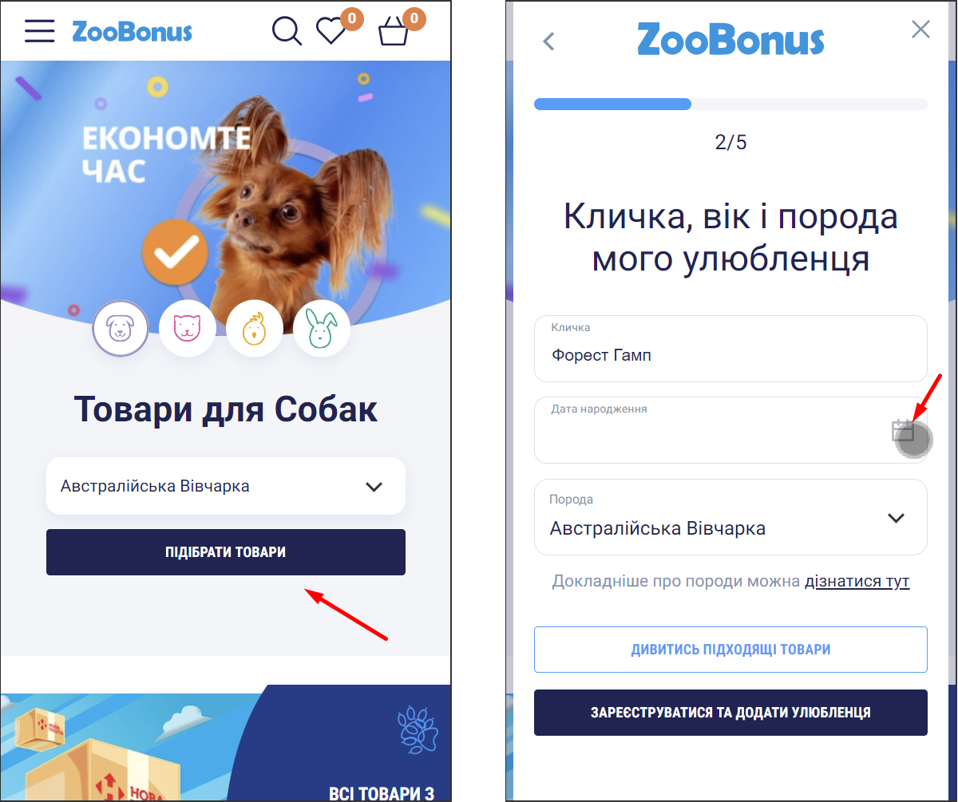

1. **ZooBonus-3**

**Summary:** Partial translation of "The birthday field is required" error below the field on the pet breed selection page.

**Priority:** 4 / **Severity:** 3

**Preconditions:** User is on “[Zoobonus.ua](http://zoobonus.ua)”

**Bug Description:** The error message for a required birthday field is partially translated, with part of the text in Ukrainian and part in English.

**STR**:

1. Navigate to the pet breed selection page;
2. Leave the birthday field empty and attempt to proceed.

**Expected Result:** The error message is fully displayed in Ukrainian: "Поле з датою народження є обов'язковим для заповнення."

**Actual Result:** The error message reads: "Поле birthday є обов'язковим для заповнення."

**Attachments:**

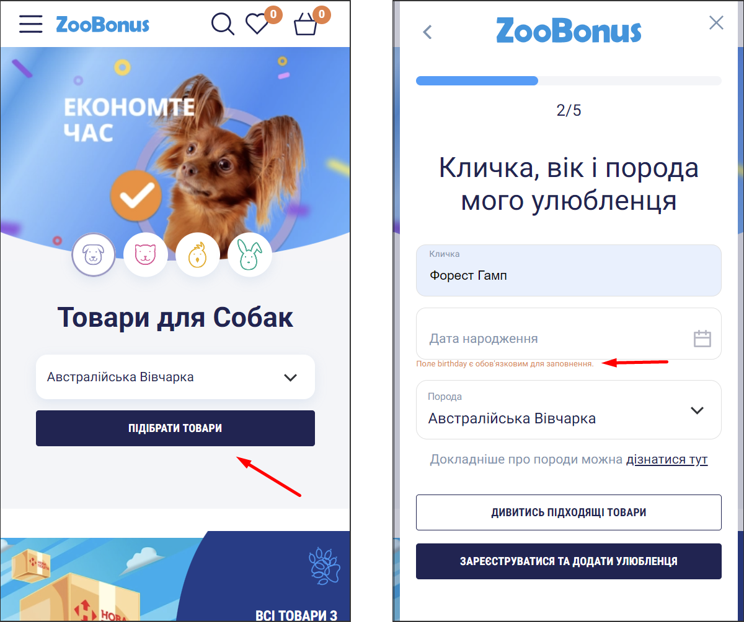

1. **ZooBonus-4**

**Summary:** Unclear symbol displayed next to "Login/Registration" text in the burger menu.

**Priority:** 5 / **Severity:** 4

**Preconditions:** User is on “[Zoobonus.ua](http://zoobonus.ua)”

**Bug Description:** An undefined or unclear symbol appears adjacent to the "Login/Registration" text.

**STR**:

1. Open the burger menu (left side of webpage);
2. Find the "Login/Registration" button;
3. Pay attention to the symbol near the text.

**Expected Result:** No additional or unclear symbols are present near "Login/Registration."

**Actual Result:** An unclear symbol appears next to "Login/Registration."

**Attachments:**

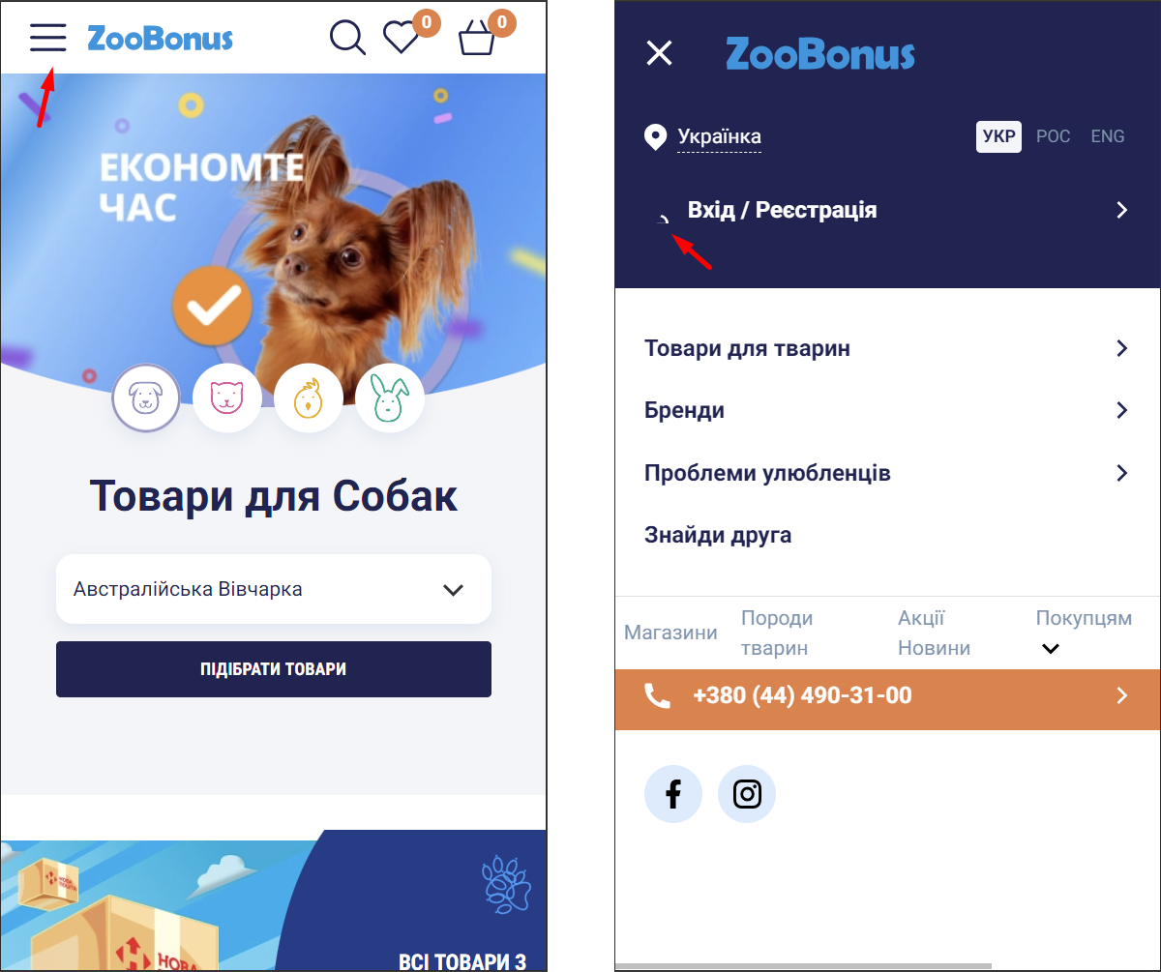

1. **ZooBonus-5**

**Summary:** Submenu "For Customers" displays incorrectly in the burger menu.

**Priority:** 2 / **Severity:** 2

**Preconditions:** User is on “[Zoobonus.ua](http://zoobonus.ua)”

**Bug Description:** The "For Customers" submenu does not display correctly, with elements overlapping or misaligned, causing usability issues.

**STR:**

1. Navigate to the burger menu;
2. Click on the “For Customers” submenu;
3. Observe the behavior and alignment of the submenu.

**Expected Result:** The submenu displays correctly, with all options properly aligned and visible.

**Actual Result:** The submenu options overlap and are misaligned, making it difficult to interact with.

**Attachments:**

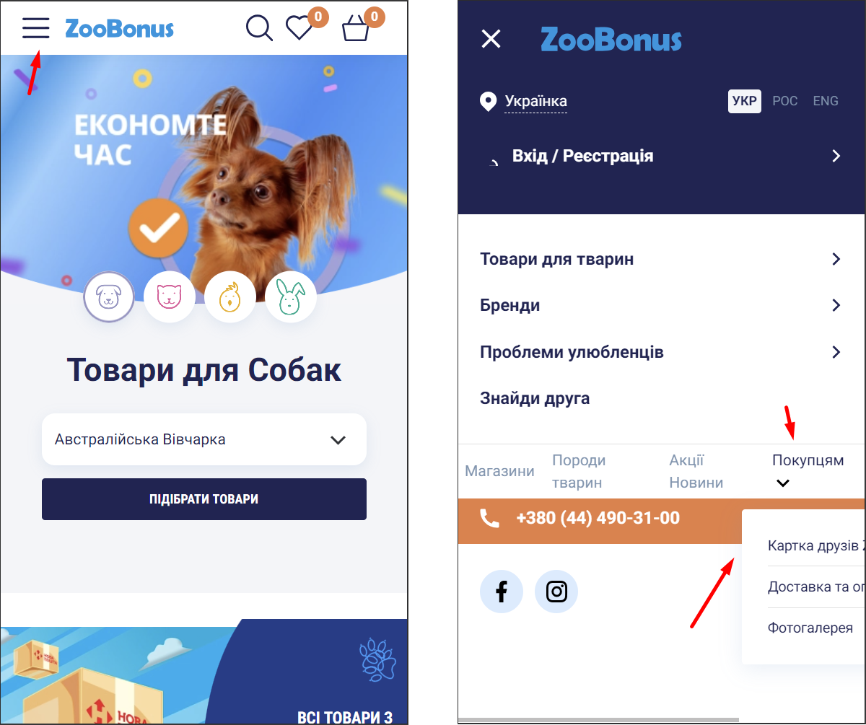

## Beet Sprout

### Встанови Android Studio за [посиланням](https://developer.android.com/studio)

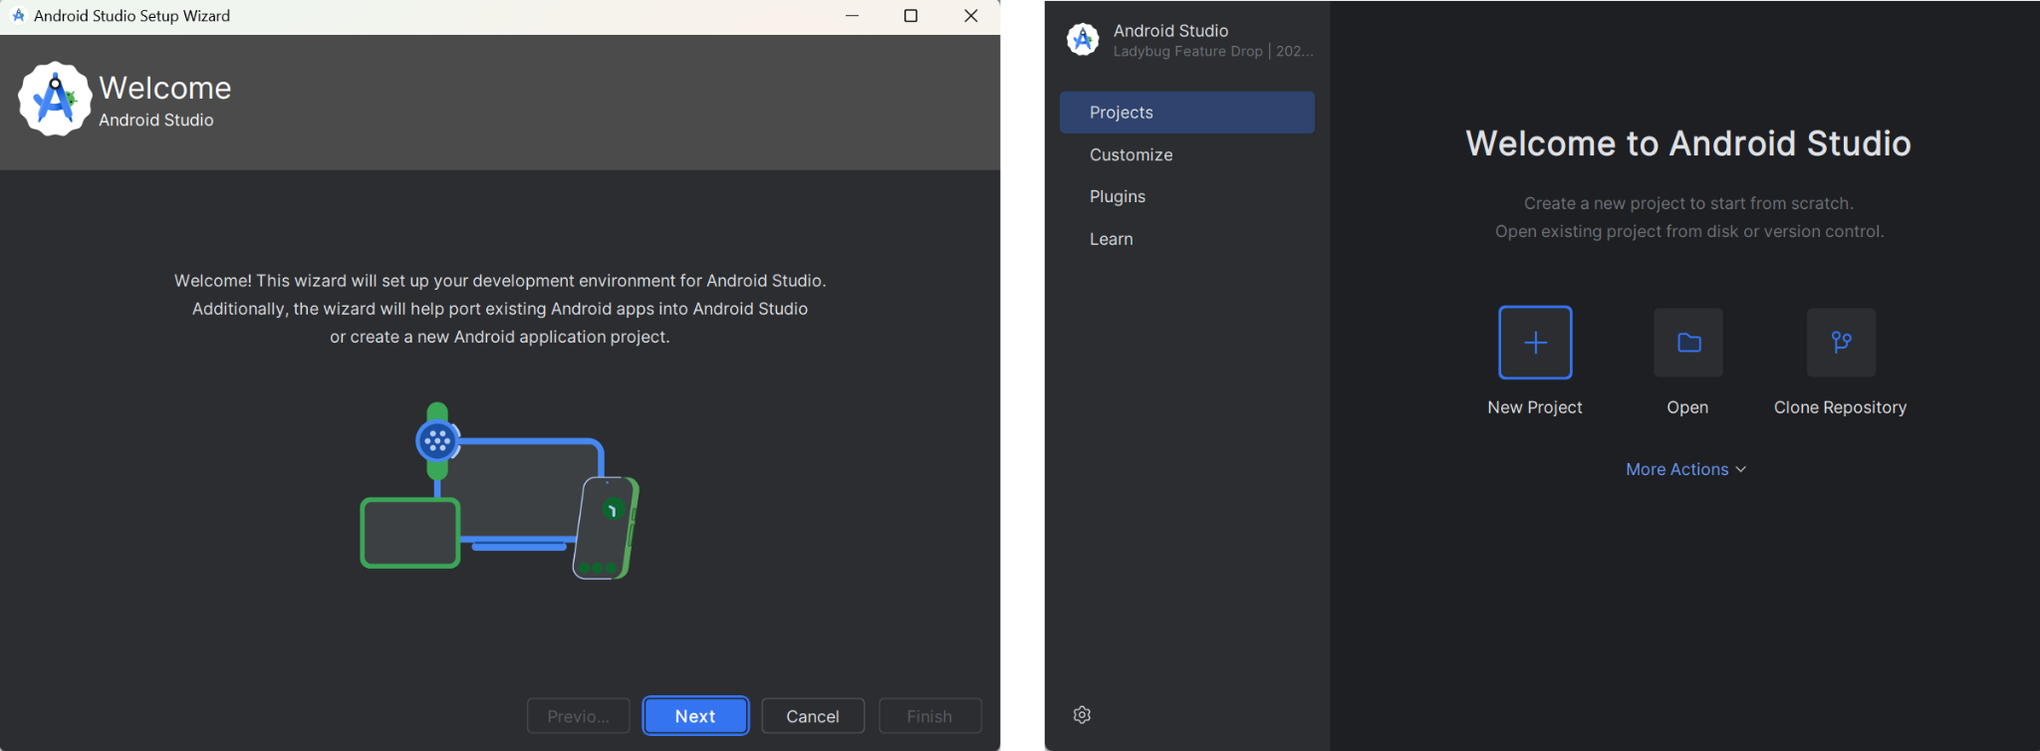

### Запусти Емулятор, використовуючи [інструкцію](https://developer.android.com/studio/run/emulator)

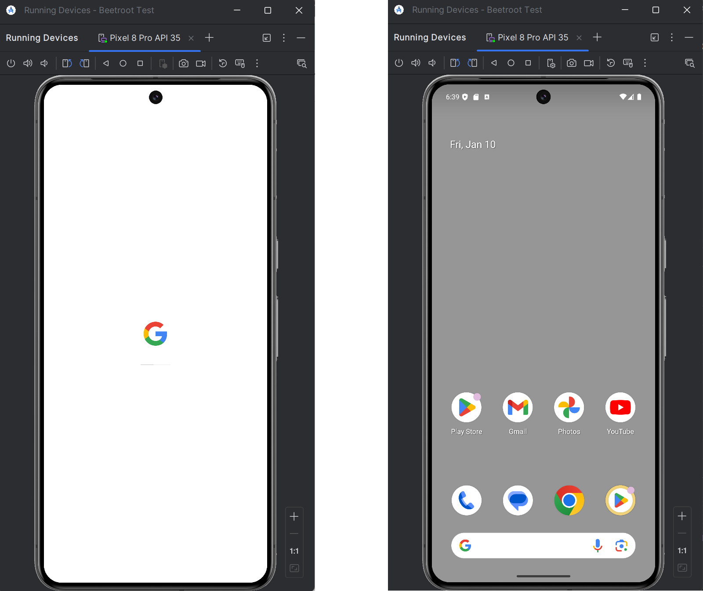

### Знайди 3 баги на сайті “[Звірополіс](http://zpolis.com.ua)”. Додай їх в документ з баг репортами з попереднього рівня

1. **Zpolis-1**

**Summary:** Two different choices are available to get in touch on the home page.

**Priority:** 4 / **Severity:** 3

**Preconditions:** User is on “[Zpolis.com.ua](http://zpolis.com.ua)”

**Bug Description:** On the homepage, the website offers two different choices to get in touch.

**STR:**

1. Navigate to the homepage of website;
2. Notice there are two choices to contact ZooPolis available.

**Expected Result:** There is only one contact choice available on the webpage.

**Actual Result:** There are two different choices to contact available on the webpage.

**Attachments:**

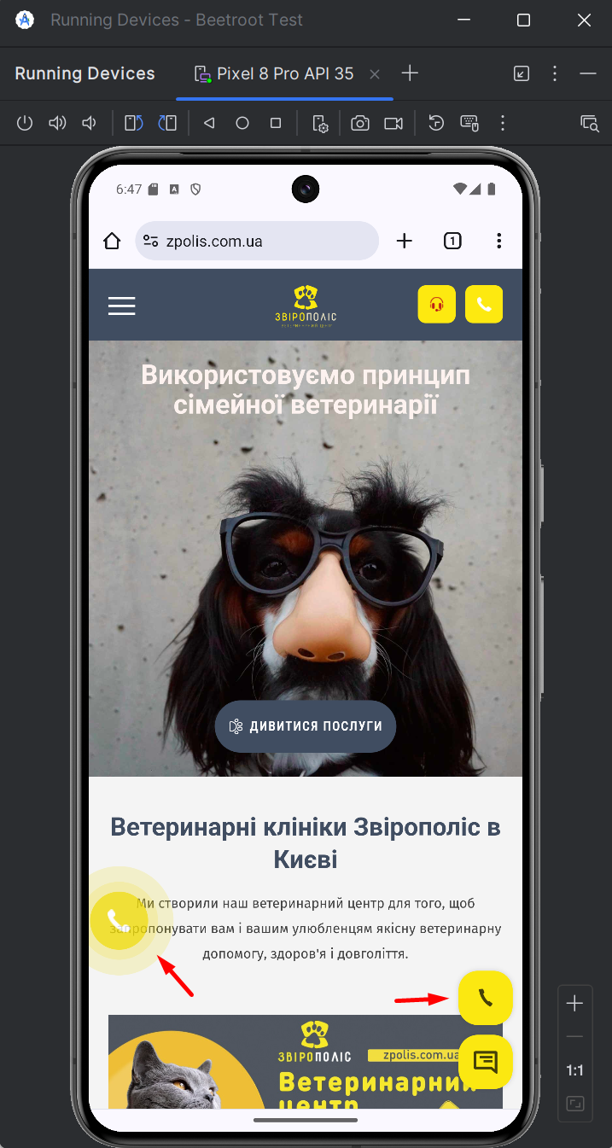

1. **Zpolis-2**

**Summary:** There are two duplicating paragraphs with the “Specialization” of the doctor “Tieror Bogdan Dmitrovich” on the main page.

**Priority:** 2 / **Severity:** 3

**Preconditions:** User is on “[Zpolis.com.ua](http://zpolis.com.ua)”

**Bug Description:** On the main website page, in the information block about the doctor “Tieror Bogdan Dmitrovich”, two duplicating paragraphs about his specializations are available.

**STR:**

1. Navigate to the homepage of website;
2. Scroll down to the “Our specialists” block;
3. Notice the two duplicating “Specializations” paragraphs in the information about the doctor.

**Expected Result:** There is only one paragraph that describes doctor’s specializations.

**Actual Result:** There are two duplicating paragraphs about the doctor’s specializations.

**Attachments:**

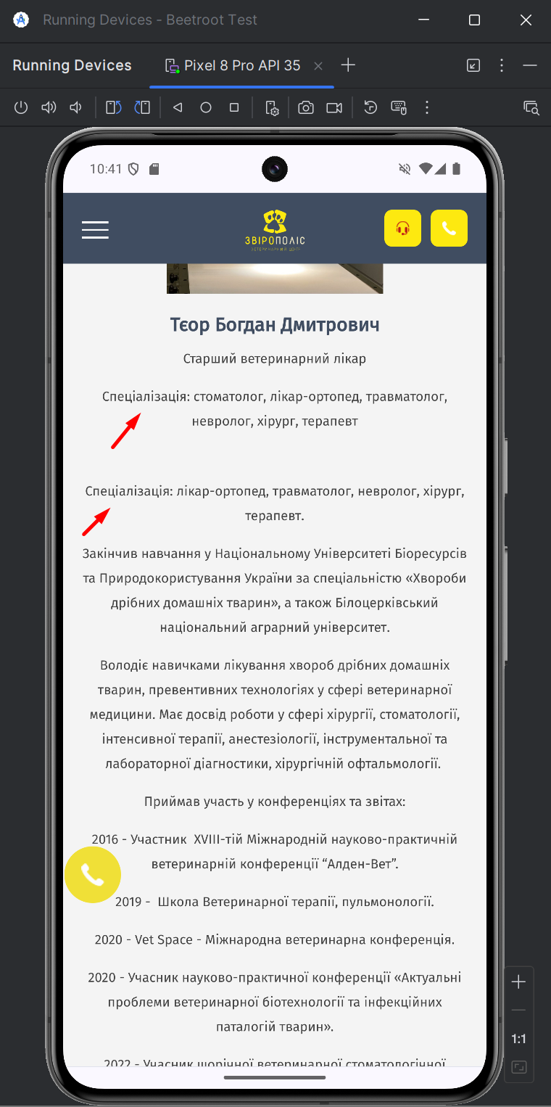

1. **Zpolis-3**

**Summary:** Too late text appearing animation of all clinic addresses on the “Contact” page.

**Priority:** 3 / **Severity:** 2

**Preconditions:** User is on “[Zpolis.com.ua](http://zpolis.com.ua)”

**Bug Description:** There is too late animation of the text in the list that contains all addresses of the clinic, if this list is scrolled to the end when located on the “Contact” page of the website.

**STR:**

1. Navigate to homepage of the website;
2. Open the menu located in left upper side;
3. Choose the “Contacts” section;
4. Scroll down the list with addresses of clinics to the end;
5. Scroll down the page so that the list is located at the very bottom of the browser window;
6. Scroll down the page slowly, and notice the unusual text appearing delay.

**Expected Result:** The text appearing delay in the list with clinic addresses is corresponding to page scrolling.

**Actual Result:** The text appearing delay in the list with clinic addresses is too late and doesn’t match the element positioning in the browser window.

**Attachments:** [**GIF**](https://drive.google.com/file/d/1WNW9kk79MORBGh9D3jKRetEfmPOYZEXv/view?usp=sharing)